Dear Parents and Carers,

We’re really looking forward to meeting and welcoming back the children in September!

To keep you and your children busy during the long, hot and sunny (we’re hoping!) summer weeks, we thought it would be a good idea to give you all a little project!

Attached to this letter is a sheet giving you information about an ‘All About Me’ box. We would really like if you could work together with your children this year to create such a box, including information about your child that will help us get to know them in their first, important days of school. Our first topic in Reception is called ‘Amazing Me’, and we hope that the boxes they will be producing will give plenty of opportunities for your children to talk to staff and their new friends about themselves; who are important to them in their lives, and what they enjoy doing.

The second page of this letter provides some information about what to include in the boxes. We hope to make a beautiful display of all the children’s work, so we will envisage keeping them in school until the end of half term, when the children will be able to take them home. With this in mind, we would suggest that you not include any priceless items, or anything the children will need on a daily basis.

If you would like to find any more information about what to include in the box, have a look online as there may be plenty more ideas.

We really hope that you will be inspired to complete this project. Your children will be able to bring in their creations when they arrive in their first week in September.

Good luck and have fun!

Kind regards,

The Foundation Stage Team

What is an **All About Me** box?  It is a box that tells us about you.  It explains who you are and what you like.

**WHAT YOU NEED:**

* **A shoebox.**  The box should be a large, adult-size shoebox.  The lid of the box should be left off.
* **Scissors**
* **Glue**
* **Tape**
* **Coloured pens and paint**
* **Some of your favourite objects**
* **Picture of yourself**

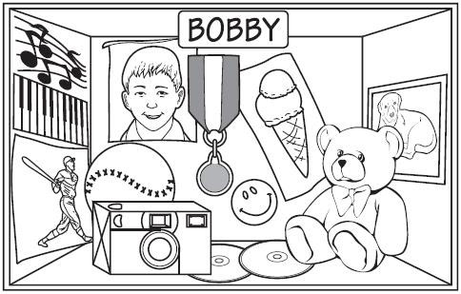

**WHAT TO DO:**1.  **Colour or paint the inside of your box.**

2.  **Turn your box on its side so that it has a floor, a roof, two sides, and a back.**

3.  **Put your name and a picture of yourself inside the box.  Use pens to write your** **name neatly.**

4.  **Now think of what makes you special.  What do people think of when they hear your** **name?  Here are a few examples:**

* Do you have swimming or dance lessons?  If so, you could cut out a picture of a swimming pool or ballet shoes and tape or glue it in your box.
* If you like to watch TV, draw a little box and make it look like a television.
* Do you like to play sports?  Place a small football in your box.  You could also glue a picture of a football player inside your box.
* If you like playing at the beach, stick a picture of a little bucket and spade in the box.
* Glue a picture of a place you have visited.
* Make a list of your favourite foods and place that in your box.
* Draw a picture of your pet(s) on the inside of the box.
* Add the name of a book, film or game you like.
* Put a small, favourite toy in your box.
* Glue a photo of yourself with a friend or family member(s).

**Use your** imagination **to think about new and interesting ways to tell people about yourself.  Bring your project into your new class to share with your new friends and teachers.**