Thursday 5th September 2024

Dear Parents / Carers

**Year 5 – Egyptian Workshop -** **Tuesday 24th September 2024**

As an introduction to our topic ‘Ancient Egypt’, Year 5 will be visited by an Egyptologist from ‘Portals to the Past’ on **Tuesday 24th September 2024** to immerse the children in a range of history activities.

This exciting experience will involve a short interactive introduction where the children will take part in a series of activities including:

* Egyptian maths – Doing basic maths the Egyptian way or measuring in cubits
* Egyptian quiz – Discover fascinating facts
* Hounds and Jackals – An Egyptian board game
* Egyptian artefacts and their way of life

The Egyptologist will reveal secrets of mummification, from the death of a pharaoh, to tomb building and decorating, the mummification process, burial and finish with the crowning of the new Pharaoh.

For this event it would be nice for the children to dress up wearing an ‘Ancient Egyptian’ costume in order to get the most out of the history immersion experience (see overleaf for free costume ideas).

We are asking for a contribution of £4.83p towards the cost of this event. Please refer to our Charging Policy for further details.  Please log onto your child’s ParentPay account to enable you to make payment for this event by**Tuesday 17th September 2024.**

We are certain that the children will greatly benefit from this opportunity and will enjoy the experience. We hope that you will continue to support us throughout the year as we strive for the best opportunities for our children to enhance their learning in and out of school.

Yours sincerely

Ms. S M Collins

School Business Director

Executive Head Teacher’s PA

**Ideas for Ancient Egyptian dressing up**

Have a look at some photos of Ancient Egyptian costumes. Try and copy some of the ideas – you don’t need to buy any expensive costumes, but adapt what you already have at home e.g. Greek/Stone Age/Roman outfits from Years 3 and 4.

If parents/carers wish to make outfits, this is what we suggest:

* You will need a length of cheap white material. Dust sheet or old bed sheets are perfect.
* Measure from the shoulders to the length required plus a few centimetres. Double this measurement.
* Girls full length, boys to mid-calf or full length.
* Measure from elbow to elbow. This will be your finished width.
* Fold material in half lengthwise. Cut out a hole just big enough for your head to go through.
* Be careful, it’s easy to make this hole too large. Start small!
* Sew up the side seams, A to B, and C to D, being sure to leave a generous armhole.
* 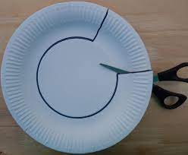Tie round the middle with cord.

[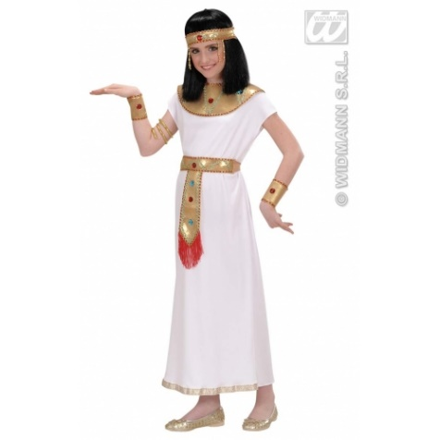](http://www.google.co.uk/url?sa=i&rct=j&q=&esrc=s&frm=1&source=images&cd=&cad=rja&uact=8&ved=&url=http://www.ebay.co.uk/itm/Girls-Cleopatra-Outfit-for-Childrens-Egyptian-Ancient-Queen-Fancy-Dress-Costume-/302206543076&psig=AFQjCNGY88tYpSq8-MAnVJTy3NLujeNcKQ&ust=1500542392933411)

We are looking forward to having a fantastic day!

