Thursday 13th June 2024

Dear Parents / Carers,

**‘Year 6 – World War II day’ on Monday 16th September 2024**

As an introduction to our topic, Year 6 will be visited by ‘Primary History Workshops’ on **Monday 16th September 2024** to immerse the children in what it was like to live during 1940s. The children will participate in a range of educational activities and will have the chance to explore genuine WWII artefacts. Also, the children will learn about how the Nazi party planned to invade Britain and how ordinary people stepped up to do out of the ordinary feats!

This exciting experience will include:

* Case studies of actual SOE agents and Home Guard Operatives
* Exploring primary and secondary sources
* 1940’s army workout
* Exploring and becoming your secret identity
* Morse code and Secret cyphers
* Planning an operation
* Storytelling

And much more!

For this event it would be nice for the children to dress up wearing a ‘World War II’ costume in order to get the most out of the history immersion experience (see overleaf for costume ideas).

We are asking for a contribution of £3.82p towards the cost of this event. Please refer to our Charging Policy for further details.  Please log onto your child’s ParentPay account to enable you to make payment for this event and give your consent by**Thursday 27th June 2024.**

We are certain that the children will greatly benefit from this opportunity and will enjoy the experience.

Yours sincerely

Ms. S M Collins

School Business Director

Executive Head Teacher’s PA

**Ideas for World War II dress up:**

Have a look at some photos of World War II costumes. Try and copy some of the ideas – you don’t need to buy any expensive costumes, but adapt what you already have at home. Here are some suggestions.

**Boys’ clothing**

* 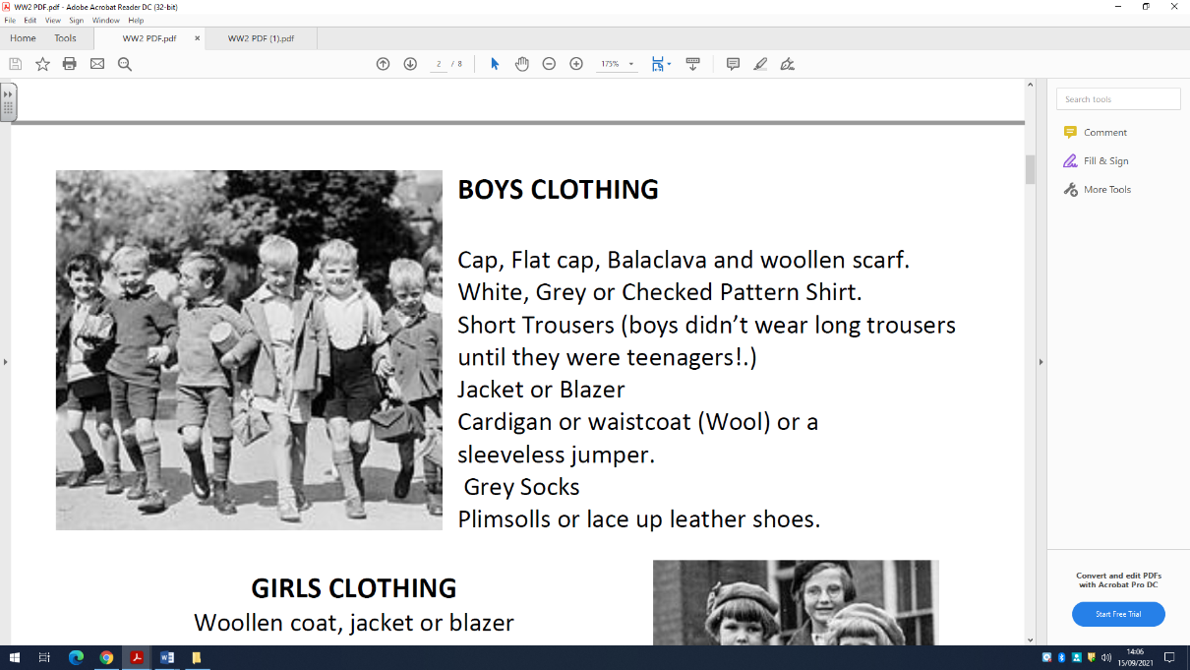Cap, flat cap and woollen scarf
* White, grey or checked shirt
* Short trousers (boys didn’t wear long trousers until they were teenagers!)
* Jacket or blazer
* Cardigan or waistcoat (wool)
* sleeveless jumper
* grey socks
* plimsolls or lace up leather shoes

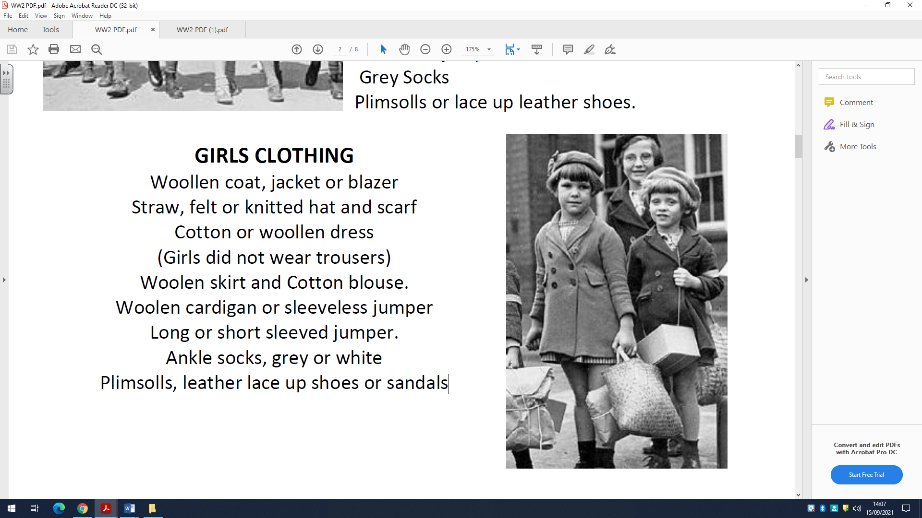

**Girls’ clothing**

* Woollen coat, jacket or blazer
* Straw, felt or knitted hat and scarf
* Cotton or woollen dress (Girls did not wear trousers)
* Woollen skirt and cotton blouse
* Woollen cardigan or sleeveless jumper
* Long or short sleeved jumper
* Ankle socks, grey or white
* Plimsolls, leather lace up shoes.