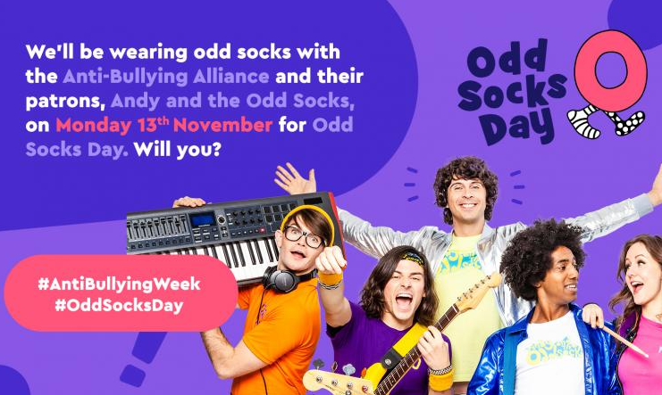

**Anti-Bullying Week is 13th November – 17th November 2023**

Whether it is verbal, physical, online or in-person, bullying has a significant impact on a child’s life well in to adulthood. The Anti-Bullying Alliance, together with Abbey, is urging action for this year’s Anti-Bullying Week and saying that by making small, simple changes, we can break this cycle and create a safe environment for everyone.

‘Make a Noise about Bullying’ is the 2023 theme and compliments the Abbey messages - ‘Be A Buddy Not A Bully’ and ‘Abbey Let’s Start S.T.O.P’. The STOP message helps us to have an assertive phrase; ‘STOP! I don’t like that’. S.T.O.P helps us to define bullying ; **S**everal **T**imes **O**n **P**urpose and it helps children to decide what to do if they feel that they are being bullied; **S**tart **T**elling **O**ther **P**eople.

Simple, everyday acts of kindness, compassion, smiling, friendship, listening to others and stopping to think before we say an hurtful word or hit ‘like’ on a hurtful social media post, can help to reduce bullying.

Odd Socks Day will be held to mark the first day of Anti-Bullying Week

CBeebies star and Anti-Bullying Alliance patron Andy Day and his band Andy and the Odd Socks are supporting Anti-Bullying Week 2023 and are encouraging children to wear odd socks to school to celebrate what makes us all unique. There is no pressure to wear the latest fashion or for parents to buy expensive costumes.  All you have to do to take part is wear odd socks to your school or workplace, it couldn’t be simpler!

