Little Bo-Peep

Little Bo-Peep has lost her sheep
and doesn't know where to find them
Leave them alone and they'll come home
bringing their tails behind them.

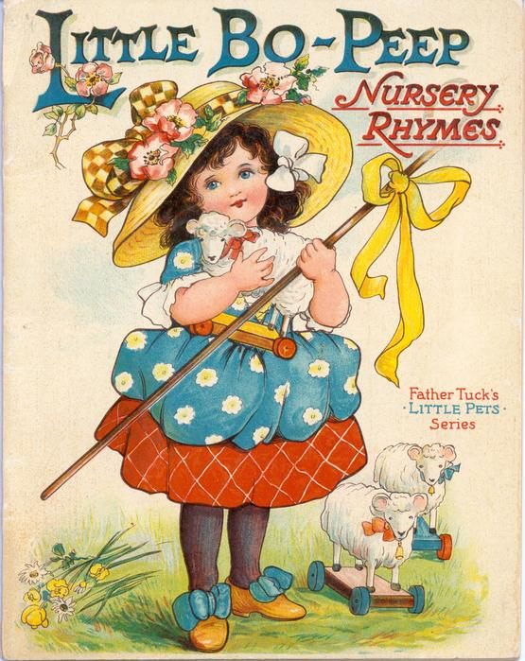

Usually Little Bo-Peep is sung.
There is a cartoon version you can listen to on you tube with your child.

https://www.youtube.com/watch?v=t7-iPbfR-yQ

