Wind the Bobbin Up
Wind the bobbin up,
wind the bobbin up,
pull, pull, clap, clap, clap.
Wind it back again,
wind it back again,
pull, pull, clap, clap, clap.

Point to the ceiling,
point to the floor,
point to the window,
point to the door.
Clap your hands together 1, 2, 3,
put your hands up on your knee.

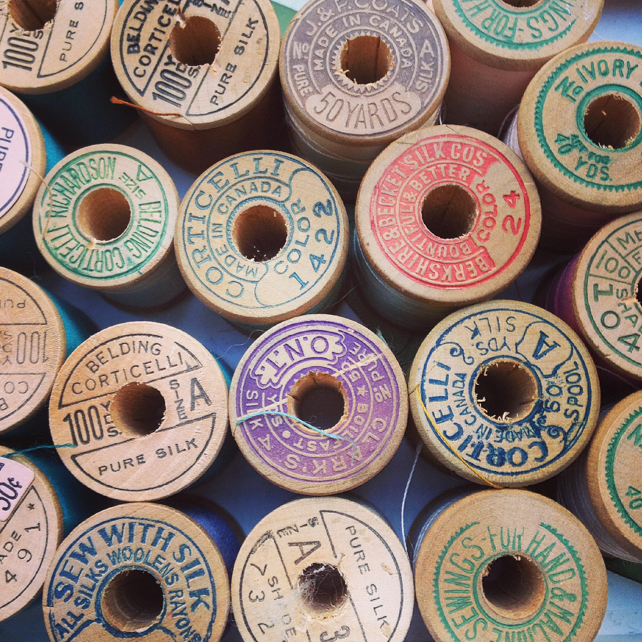

Usually Wind the Bobbin up is sung.
There is a cartoon version you can listen to on you tube with your child.

https://www.youtube.com/watch?v=wR9HI9IkmH8&safe=active

