Tuesday 1st October 2024

Dear Parents and Carers

As part of our Design Technology work, the children in Year 3 are going to design, make and evaluate a model bridge. The children are currently learning about bridge structures and what makes a strong, functional bridge.

We would like to invite you to come in and help your child to make their model bridge using a range of resources such as; balsa wood, glue guns, hack saws and clamps. The sessions will be taking place on the following days; **Tuesday 19th November (3W), Wednesday 20th November (3S) and Thursday 21st November (3G), all of the workshops will start at 1.30pm-3.00pm.**

Due to numbers and hall space, we ask that only one adult per child attend the workshop. Unfortunately, due to health and safety, we also ask that no siblings or other children attend.

We are asking for a contribution of £3.00 towards the cost of materials, please refer to our charging policy for further details.

Please log onto your child’s ParentPay account to let us know that you will be attending by **Tuesday 5th November** in order for the teachers to be able to accommodate all of those who wish to attend.

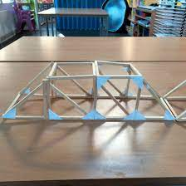

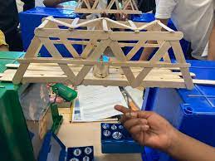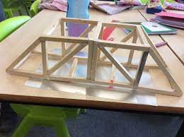

Yours sincerely

Ms S M Collins

School Business Director

Executive Head Teacher’s PA